About S

Her profession is scientist and scholar (Gaz1 p4), and she has a degree in Il Aluk University, Brautslava Institute (Gaz2 p4). She studied Il Aluk for 5 years (Gaz1 p4).

About her personality, we can be sure she is very confident in herself (Gaz1 p4), a highly intelligent but cold, analytic person. Probably low charisma (Azalin writes about S’s "frosty demeanors" (Gaz1 p23)).

Mangrum adds: S was female from the outset. (All of the major beats in her character arc/the Gazetteer metaplot were known to the authors from the outset.) S doesn't seem particularly "feminine" because A) she's a reflection of Azalin, both literally and symbolically, who doesn't have a feminine bone in his body; B) since her gender was kept a mystery until Gaz 3, her "all business" tone was a requirement of the narrative, and C) all of her authors were male, depicting a character who was decidedly not intended to be in touch with her feminine side. (As opposed to how I approached the Weathermay twins, Gennifer in particular.) We did our humble best.

She is known to be able to cast spells ("paralysis" on a wolfwere (Gaz1 p92) - hold person ? hold monster ?); scrying on monks (Gaz1 p42), produce "arcane flame" on Gremishka (Gaz1 p69).

However, she was refused in the Fraternity of Shadows, because they are "trapped in antiquated modes of thoughts" (Gaz2 p28) (i.e. because the FoS doesn’t accept women within its rank).

Miscellaneous combat abilities notes: she has pistols; and has killed shadow feys (Gaz1 p77).

S was married; "Indeed, this is how I found my spouse" (Gaz2 p28). On her daughter, S's daughter was killed by a controlled ghoul Kargat who broke S's control (Gaz2 p57). This daughter, now a ghoul, lives in Necropolis (Gaz2 p62). From the author’s notes: S was married off in an arranged marriage to a rather meek, if rich, Darkonian husband who knew better than to interfere with her research. He's out of the picture now and unmissed.

On her name, JWM: for the Kargatane, her name has always simply been "S." If she was ever to have been given a full name, it would likely have been her final sign-off at the end of Gazetteer XIII. But honestly, by that time it would have been an afterthought. Her name is just "S" to us.

Ryan Naylor :

I've never understood the confusion about whether Our Hero was evil or not. She's evil. She dissects living things for the hell of it. She sacrificed her daughter in an experiment on undead (albeit unintentionally, and as of Sithicus and Keening, is starting to regret it), and then rather than put her out of her misery, tried to use her as a proxy to investigate the Shroud.
She's cold and arrogant, with no time for stupidity or social niceties. She seems to have turned into a borderline alcoholic, which was I think unintentional and moderately amusing. Despite all this, she is quite good at getting people to talk to her. She's driven by curiosity / lust for knowledge. Does this sound like anyone we know yet?
She is the illegitimate daughter of a Darkonese nobleman (erm, that is, the people who raised her are Darkonese nobles).
Matthew L. Martin: S is one of the clones from the same project that produced Lowellyn Dachine. Since she was an aberration -- she was one of the last clones and a female clone -- Azalin took little interest in her during his pre-Requiem existence, assuming there was very little of himself in there. That's why she's the only clone left alive and sane. After his emergence from his time merged with Darkon, he decided to use her to track down the Dukkars . . . and groom her for her next role.
Mangrum: Unlike the illustrations that have actually appeared in the books (with the exception of Talon's portrayal in Gaz II - the illustration of her encounter with Adam), this one actually fits how she's depicted in the text.

In Gaz III, why is she wearing a veil? I have no idea. (For that matter, why does she consistently wear Dementlieuse fashions in all but Talon's illustration? No idea.)

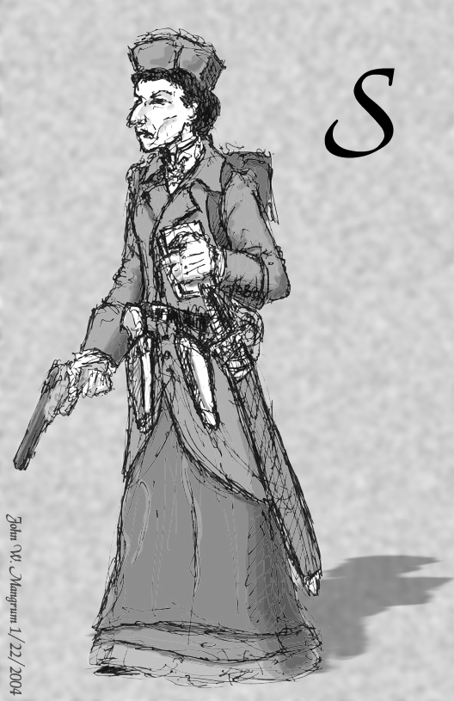
Rough version, including design notes:



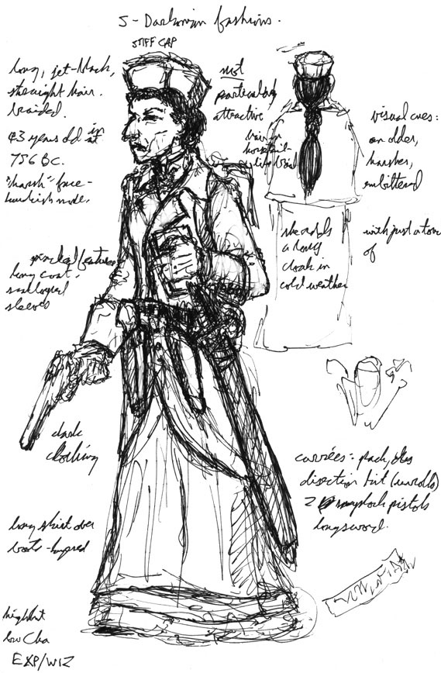

In the latter, one note reads: "visual cues: an older, harsher, embittered _______ with just a touch of _______." I drew this sketch on the bus one night, and couldn't remember the names at the time, but to fill in the blanks, the first blank is "Claudia Black" and the second is "Margaret Hamilton." (aka the Witch in Wizards of Oz)

About Azalin’s ultimate plans for S

Ultimately, the Gazetteers aren't about the catastrophic end game -- they're about S herself.

Readers also only saw the first third-ish of S's story, with the series ending during one of her darkest moments. A dawn, of sorts, was yet to come.
(John W Mangrum)

Some more hints from the Gaz:

The fortune teller can't see S's death or is puzzled by what she "sees" (Gaz2 p47)…

"I have obtained full knowledge of the actual facts behind Azalin's downfall and eventual return” (Gaz1 p4); "Your value has not escaped my attention" (Azalin's quote, Gaz2 p4).

After S asked if all this is a test, Azalin quote: "Indeed, the first of many. Your recognition of that fact was the second" (Gaz2 p5)

The plan for S’s trip (and the released Gazetteers), including inside notes by JWM:

Gaz VI (late 2004; winter 758-759)
Liffe, Vechor, The Nocturnal Sea (including Graben / Todstein, L'ile de la Tempete, the Isle of Ravens, etc.)
John: Shay-Lot (Maybe? What do you guys think? If so, we need to start brainstorming what's actually down there.)
In this book, Azalin provides S with a ship and crew that sticks around until halfway through Gaz VIII. I'd like us to start thinking up little character notes that we can use to personalize these folks a bit while they're around. These folks work for Azalin, so use that as a starting point. And any thoughts on the ship's name?

Gaz VII (early 2005; spring-fall 759)
Sea of Sorrows, Blaustein (short), Ghastria (short), Dominia, Markovia
...and then we're completely done with the Core.

Gaz VIII (late 2005; winter 759-760)
Souragne, Saragoss, Sri Raji, The Wildlands
John: Gaz VII moves into the Clusters, with S first appearing in Saragoss. She would then abandon the ship and the rest of the crew in a scheme to escape into Sri Raji.

Gaz IX (early 2006; spring-fall 760)
G'Henna, Har'Akir, Sebua, Pharazia

Gaz X (late 2006; winter 760-761)
Nidala, Avonleigh, Shadowborn Manor, Odiare

Gaz XI (early 2007; spring-fall 761)
Paridon, Timor, Vorostokov, Sanguinia

Gaz XII (late 2007; winter 761-762)
Farelle, Rokushima Taiyoo, I'Cath, (new domain)

Gaz XIII (early 2008; spring-fall 762)
Staunton Bluffs, (new domain), (new domain), Bluetspur

John W Mangrum gave many hints on S’s story during the years:

- Had we kept to the schedule of two gazetteers a year, the series would have concluded in 762 BC - thirteen years before the Time of Unparalleled Darkness.

- The ToUD has always been and remains nothing more than an idea seed for DMs -- no one that I know of (with the exception of Steve Miller, for the initial adventure concept that eventually became Die Vecna Die) has put much thought into its details. (Just about all of my thoughts concerning the ToUD are actually in R3E, seeded in the History section.)

- That said, the general idea that's been simmering for quite a while is that the ToUD, unlike the Grand Conjunction, would not be a singular event. Rather, it would be the culmination of a long series of terrible events, each one making the world a worse place. One way to look at it -- if every Dread Possibility comes true in your campaign, you're setting the stage for the ToUD.

- Azalin's plan, should it succeed, would be one of the events making life worse in general.

- If Azalin's plan succeeded, some groups of people would never notice. For other groups, however, Azalin's success would spark catastrophic fallout.

- As an example of possible fallout, Azalin's success would likely spark a war across most of the western Core, which would in turn probably crush Borca. This war has nothing to do with Azalin's plans whatsoever -- it's just a logical side effect of his intended actions, one of no personal significance.

Why Borca would get crushed in the looming war of the western Core really isn't a mystery -- it's pretty explicitly laid out in Gaz IV (and in Gaz II, add Chris Nichols).

Gazetteer Volume IV, Page 32:
Lord Ivan reportedly wants to place an open bounty on Aderre's head, but the Invidian tyrant hides behind his alliance with Drakov. Should Ivan overplay his hand, he may well provoke Falkovnia and Invidia into closing their jaws around Borca, an assuredly brutal conflict.

Gazetteer Volume II, Page 103:
Recently, Drakov's ever roving eye has turned again south; his inner circle of generals is making plans for Dementlieu to demonstrate the folly of the Treaty. Dementlieu is prepared to come to the aid of the other Treaty domains in the event of Falkovian aggression. Unfortunately, economic necessity demands that Dementlieu import grain and other crops from Falkovnia, in addition to other trade relations.

Gazetteer III, Page 29:
Shoud Drakov discover [Josephine Chantreaux's] activiteis, Josephine risks triggering a new attack from Falkovnia. She is acutely aware of the risk, but her childhood anguish will not allow her to do any less against the cruel tyrant.

- Escape from the Demiplane of Dread is not part of Azalin's plan. (Which is not to say it doesn't factor into anyone's plans -- there are several movers and shakers here, each acting toward their own ends.) By now, Azalin's figured out that even if he did escape, who's to say his "tormentors" wouldn't just snatch him up again?

- The children of the Gentlemen Caller do figure into it. In Gazetteer VI, the reader would have learned just how many children were out there/Azalin needed to find. In Gazetteer VII, S would have learned as well, and both she and the reader would have discovered the exact purpose of her magic bracer. This would have kicked off the latter half of the series, with S visiting the clusters and islands.

- As an unrelated side note, Gaz VI would have also introduced a supporting cast that would have stuck around until about halfway through Gaz VIII -- the crew of the ship Azalin supplies to cart S about the seas.

- In my personal notes, I considered Gazetteer XIII a good place to end Ravenloft Third Edition. Particularly since D&D 4th Edition would likely be approaching (or here) by then, were RL still going at that point, I would have bumped the timeline forward to 765 BC and handed the reins off to the next generation of designers to launch Ravenloft Fourth Edition, which likely would have focused on the imminent "end days" of the setting.

- According to plan (which I later managed to muddle), there would be one child of the GC in each Gazetteer (thanks to my deadline issues, Gaz III ended up with none, and Gaz IV got two).

- The first child (the one in Gaz I) is, as some have speculated, the batwinged Beast of the Hills. Not that there's any way to tell from the book. The Kartakass chapter originally included a bit more on this character, but as it stands she narrowly avoided being edited out of the book altogether.

- A concept I eventually formulated was that in terms of exact nature, powers, and personality, each individual "demonspawn" was an amplified reflection of its Vistani mother's worst fears and failings. Malocchio Aderre is the only one who actively seeks the destruction of the Vistani, because he's a dark reflection of the worst aspects of his mother, Gabrielle, and he's the most powerful, because he reflects the power of his mother.

- The general idea of the Beast of the Hills, since it's moot now, was that her demonic nature manifested almost entirely physically. Most of these "dukkars" look normal (save for some minor physical deformity), but have utterly fiendish souls; this one is physically fiendish, but inwardly lacks her father's malice. In hindsight, I'd assume her mother had serious self-esteem issues.

The Beast's lost Dread Possibility went something like this: The Beast had retreated to Radaga's old haunting grounds to avoid civilization. However, the artifact Radaga possessed (the stone slab she used to steal the youth and vitality from damsels strapped to it) was empathically calling out to her (as evil artifacts are wont to do), trying to convince her to use it to give herself a normal appearance.

- S was scheduled to have a brief encounter with Carnival in one of the latter gazetteers, using it once to travel through the Mists.

- Had the series reached its planned end with Gazetteer XIII, S's story would have ended very badly for her. Very badly indeed, but it was a fate she would have freely chosen to accept, rather than being the result of an inevitable curse.

- As for the very, very end of the tale, a puzzle I always had percolating in the back of my head was how to best express, within the books' format and Arthaus' unpredictable graphic design choices, Azalin screaming with boundless rage.

Fans guess: S's adventures would end with her incorporation into the God-brain, which would certainly fit the bill for "horrible end". That would also fit the bill as "conscious choice" and "likely to send Azalin insane with rage". She can't just get herself killed, or suicide, as the bracer will clone her again. She has to be trapped in something.
This was the intent by the time the Gazetteer metaplot was set: feeding herself to the God-Brain would have kept Azalin from pulling her soul back to Avernus.

Matthew L. Martin : This last report wouldn't have been full--S would have concealed the identity of the thirteenth Dukkar. And even if Azalin found that out another way (and getting the thirteenth would be the harder part, most likely), he still wouldn't have been able to use S for the real purpose he had in mind for her.

- Very, very early in the Gazetteer development cycle (pre-Arthaus), we pencilled in a plan to wrap up the Gaz series with an adventure that would have directly involved S, Azalin, the Dukkars/demonspawn/children of the Gentleman Caller, and other major players (including the Tribe of Hyskosa). However, that was quickly dropped; by the time we actually started prepping the series for publication, S's story and the Gazeteers were fated to end at the same point.

For the record, over the course of three years, one fan has publicly guessed the whole Gazetteer metaplot correctly. (Disturbingly so, in fact!) It was Grey Arcanist.

Ryan Naylor adds:

- I think it is a real pity that the gazetteers were never completed, since Our Hero had all sorts of exciting adventures ahead of her (I was particularly looking forward to Blaustein, which is the highlight of her story for me). But considering that after the Great Falling Out, the gazetteer writers weren't even really aware of the metaplot, I'm not sure it would have lied up to my expectations.

- For some reason, Azalin is interested in her and holds high hopes for her progress around the Core. This quest (which, knowing Azalin as we do, can only involve an escape attempt from Ravenloft) somehow involves the Gentleman Caller and his children and various dukkars and Vistani outcasts, including the Tribe of Hyskosa who are dedicated to thwarting Azalin's schemes.

- For what it's worth, I see the Gentleman Caller's place in Ravenloft as a trap to get Isolde stuck there, and having achieved that but failed to destroy her entirely, he now wants to get the hell out. So that could give you more a clue as to what Azalin plans. Or it may be a red herring.

- For what it's worth now, the bracer (as Rock said) just downloads her memories into a clone in Darkon. While the clone's still waking up, the Kargat ship her of to wherever she died (Valachan, in this case) and dump her somewhere nearby. Having cleaned out the house first, of course, which is where the blood spot on the floor came from.
Mangrum: It operates as a variation on a lich's phylactery, with a touch of magic jar, which is how Azalin was able to create it. Upon the wearer's death, it transfers the wearer's soul into a waiting receptacle back in Avernus. That soul is then placed in an inactive clone body. Without that soul, an awakened clone would just be an evil duplicate, as detailed in the core RL rules.

- John had a really great idea about Blaustein, where S went back and found herself face to face with her own bloated corpse that I wish had made it into print.
Mangrum: Actually, S wasn't going to be killed -- she was going to commit suicide as an act of defiance upon realizing that Azalin had shackled her to a seemingly impossible and unending quest.

And the plan was for Gazetteer VI: The Stormy Seas:

- Azalin supplies S with her own ship and crew to cart her around. They stick around into the next gazetteer.

- S now knows that Azalin is looking for something specific, but not what exactly.

- Azalin ups the ante. Until now, S has been engaging in a survey of "the Core." Now Azalin tells S there are still "others" out there, and she'll keep looking until she finds them. She's trapped in this job until she's searched the *entire* (boundless, uncharted) Land of Mists.

- Defiant, she thinks back to how her daughter died. S-girl was attacked by one of S's interrogation subjects and mortally wounded. S-girl begged her mother to let her die -- to let her rest in peace. S wouldn't do it. S sent her daughter into Il Aluk, thinking the Slain City would preserve the girl's intelligence (let's pencil in that she was turning into a ghoul). S also hoped that this would give her a cooperative agent within the city. Didn't work. Undead S-girl just gave her mother one rueful glare, then walked off into the heart of the city, never to be seen again.

- S isn't going out that way. She determines her own fate, by golly, and she'll be no one's slave. S tosses herself off a cliff into the crashing surf far below.

- S wakes up on the same island a week later, unharmed. Flabbergasted, she returns to the cliffs and searches the rocks, trying to see how she could have possibly survived. S FINDS HER OWN BROKEN, WATER-LOGGED CORPSE.

- S realizes she's trapped. Death is no escape; Azalin will just keep bringing her back until she's done.

- S is defeated, for now, but she's still plotting to extricate herself from the situation as the ship takes her into the Misty Border, headed for the lands beyond.

And finally, the Gaz game plan, by JWM!

- We hadn't worked out all the kinks, but the basic plan was that the Gentleman Caller was trying to breed his way out of the demiplane. His first attempt, Malocchio, was also the closest he'd came to success, since the mother was herself so powerful. However, since Malocchio ended up such a disappointment, he'd set his eyes on the only woman in the demiplane who could produce a demonspawn guaranteed to escape Ravenloft: Madame Eva. (It's not *that* icky -- taking into account that Eva is "as old as she feels," while under the GC's sway she would revert to a youthful, vibrant appearance.)

- The problem with that plan is that Eva didn't fall off the turnip truck yesterday, so the GC is stymied as to how to get at her.

- The basic arrangement that Azalin and the GC were going to enter into was this (we didn't work out all the details):

- Azalin would somehow help the GC seduce Madame Eva.

- While the GC keeps Madame Eva out of commission, the power of the magic trapping Malocchio Aderre in Invidia would be weakened. Azalin and the GC would then break the spell, freeing Malocchio again.

- This would be a necessary step in gathering all thirteen existing dukkars in one location, creating a "blind spot" that not even the Dark Powers could perceive or affect.

- While hidden from the DPs (and freed from his curse), Azalin would develop a spell --sort of an arcane, forced /reincarnation/ -- that would stick Irik's spirit in another sort-of-cloned baby Azalin would create, with himself as the father and S as the mother.

- That was Azalin's *plan*, anyway. In the metaplot-as-written, he never gets to try it (because S sacrifices herself to the God-Brain without revealing the identity of the thirteenth dukkar).

- Mathew, on the crush of Borca: John had the mental image of Azalin picking an infant Irik up from among some ruins, but I don't believe they ever worked out the details.

Follow-up notes, again from John’s files:

- Considering how close Azalin is by the end of the Gaz storyline--he knows the identities of 12 of the 13--one would think S' last middle finger to her patron/progenitor/father/twin would only be a stumbling block, not an absolute disaster. Couldn't Azalin determine the identity of the thirteenth with other minions, or by some other means?

- Otherwise, it's a bit like setting out to build a house and then tearing the whole thing down when you don't have enough bricks to finish the chimney.

- Well, theoretically true, but -- at least as I saw it -- the missing 13th dukkar has been watched over by a ghaele eladrin since before his birth, and she's been taking great care to ensure that he never falls into evil hands. Plus, since he's been protected by the skurra-vera since the moment he was born, the Familiar's fiendish nature has never been able to manifest, so he's pretty much completely under the radar. (This is also why she doesn't just kill him -- until/unless his fiendish heritage is unleashed, he's basically an innocent bystander in all of this.)

- Another weak link in the plan was that the Beast of the Hills -- the most outwardly fiendish of the 13 -- wasn't evil at all, and wouldn't have gone along with the plan either. Add in that Malocchio is still trapped, and that freeing him requires taking down Madame Eva (whose powers, in their own way, certainly rival Azalin's), and that the remaining ten dukkars aren't inclined to cooperate like good little children to begin with, and Azalin definitely has a lot of loose threads to sew up (which he wasn't going to get to do within the scope of the Gazetteers).

- Ultimately, I saw the Gazetteers as being more specificially about S and her moral journey than as being about the grandiose metaplot going on in the margins, so that's where my focus went.

- I never much thought about events post-S's self-sacrifice circa 762 BC. By then, I assumed 4th edition D&D would be imminent (if it hadn't already arrived) and that the end of the Gaz series would likely coincide with the end of 3rd edition Ravenloft.

- For what it's worth, I liked the idea of Azalin actually *succeeding* and momentarily beating the Dark Powers at their own game. He *would* get a second chance to raise Irik in his own likeness, though likely at dire cost (to himself, the western Core in general, Darkon in particular, and the Vistani). Of course, that doesn't mean Irik wouldn't turn out to be just as good-hearted as he was the first time around. If Azalin *did* succeed in 762 BC, Irik would be 13 at the time of the ToUD in 775 BC. (Whatever that would have meant.)

- As for Van Richten's role in the ToUD, I never thought about it much (or, for that matter, the ToUD in general). The most consideration I ever put into his role was that at the darkest hour, he might simply entreat some darklord -- likely Azalin -- to recall his better nature and get him to back down from some truly apocalyptic deed. I also favored the "de-aging" ending of Bleak House, which I think would put Van Richten in 775 BC back at roughly the same physical age he was at when Baron Metus killed his son and kicked off his monster slaying career -- about 35, I think. (Whatever that would have meant.)

About those 13 sons of the Gentleman Caller

Fans were able to quickly identify these NPCs as son of the Gentleman Caller: Vigo Drakov, Malocchio and then after more investigations: the Beast of the Hills and the Jongleur.

Mangrum: Chezna is one of the thirteen. She was a darkling in the same product that said Nova Vaasa has five moons. (The Awakening - pp21-22, in which she is the leader of the Briarweed forest bandits)

Mathew L. Martin gave a hint: The last plans were for the Thirteenth Dukkar to be a character who has seen print . . . but whose abilities are generally latent and who is in a situation that would make it tricky for Azalin to get a hold of him…

And then the answer to this riddle: From John Mangrum's notes to the Kargatane: Gazeteer VI-XIII: Who knows? I did figure that the thirteenth dukkar, who S would encounter but only hint at in her reports to Azalin, is the Familiar at Isolde's Carnival.

Matthew L. Martin: If you take what we know of the Dukkars whose parentage we can deduce, you should be able to extrapolate the parentage of the Ultimate Dukkar.
Just a side note: "Ultimate Dukkar" is my term, not the Kargatane's--it's just my shorthand for "GC child powerful enough to get him out of Ravenloft." I don't know what such a child would mean for the Vistani.

Child of the GC: | Deformity | Land | Mother | Maternal Grandmother  /Grandfather
Beast of the Hills  (Gaz 1) | monstrous | Kartakass | Vistana or 1/2 Vistana with low self-asteem | ?/?
Vigo Drakov (Gaz 2) | fiendish | Falkovnia | 1/2 Vistana (Isabella Aderre of Zarovan Linegage) | Vistana?/Giorgio?
Jongleur (Gaz 4) | 'scarring' | Borca | Vistana or 1/2 Vistana | ?/?
Malocchio (Gaz 4) | 6 fingers | Invidia | 1/4 Vistana  (Gabrielle Aderre* of Zarovan Linegage) | 1/2 Vistana Isabella Aderre  /Darklord Vlad Drakov
Chezna (Gaz 5) | redhead | Nova Vaasa | Vistana | Vistana/Vistana
Other 7 GC child ???  (planned Gaz 6-12) | ??? | ??? | Vistana | ???
The Familiar  (planned Gaz 13) | repressed | Carnival | Vistana Crimson Rose of Naiat tribe | Vistana/Vistana

* Gabrielle's father was Vlad Drakov, at least in RL 3E, although they never wanted to make this too explicit.

Matthew L. Martin: Could it be that the Gentleman Caller had Dukkars with both mother and daughter? He did. Which means that Vigo Drakov and Malocchio Aderre are half-brothers by actual paternity, uncle and nephew by maternity, and uncle and nephew by legal paternity! ☺

The reason for the Gentleman Caller to select those two mothers? It was the Zarovan legacy, as Gabrielle is linked to madam Eva. Mixing Zarovan blood with fiendish essence could cause some very serious power to be formed...

